REACT

GETTING STRATED: CREATING A NEW PROJECT

TERMINAL:

check if you have node JS node -v

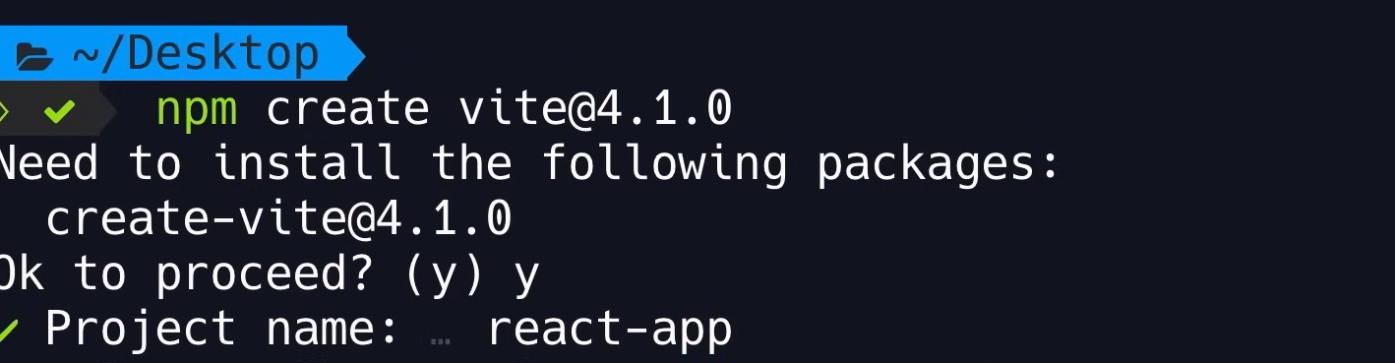

npm create [vite@4.1.0](mailto:vite@4.1.0) y project-name

select framework and language

got to folder containing your project cd project-name

install libraries: npm install

open in vs code code .

in vscode TERMINAL:

run web server npm run dev

INSTALL BOOTSTRAP npm i [bootstrap@5.2.3](mailto:bootstrap@5.2.3)

Import into main.tsx 